**Face Mask Detection**

**To download the dataset**

!git clone https://github.com/misbah4064/face_mask_detection.git

%cd face_mask_detection

**Train the model**

import cv2

import os

from tensorflow.keras.preprocessing.image import img_to_array

from tensorflow.keras.models import load_model

from tensorflow.keras.applications.mobilenet_v2 import preprocess_input

import numpy as np

from google.colab.patches import cv2_imshow

faceCascade = cv2.CascadeClassifier("haarcascade_frontalface_alt2.xml")

model = load_model("mask_recog.h5")

def face_mask_detector(frame):

  # frame = cv2.imread(fileName)

  gray = cv2.cvtColor(frame, cv2.COLOR_BGR2GRAY)

  faces = faceCascade.detectMultiScale(gray,

                                        scaleFactor=1.1,

                                        minNeighbors=5,

                                        minSize=(60, 60),

                                        flags=cv2.CASCADE_SCALE_IMAGE)

  faces_list=[]

  preds=[]

  for (x, y, w, h) in faces:

      face_frame = frame[y:y+h,x:x+w]

      face_frame = cv2.cvtColor(face_frame, cv2.COLOR_BGR2RGB)

      face_frame = cv2.resize(face_frame, (224, 224))

      face_frame = img_to_array(face_frame)

      face_frame = np.expand_dims(face_frame, axis=0)

      face_frame =  preprocess_input(face_frame)

      faces_list.append(face_frame)

      if len(faces_list)>0:

          preds = model.predict(faces_list)

      for pred in preds:

          (mask, withoutMask) = pred

      label = "Mask" if mask > withoutMask else "No Mask"

      color = (0, 255, 0) if label == "Mask" else (0, 0, 255)

      label = "{}: {:.2f}%".format(label, max(mask, withoutMask) * 100)

      cv2.putText(frame, label, (x, y- 10),

                  cv2.FONT_HERSHEY_SIMPLEX, 1, color, 2)

  cv2.rectangle(frame, (x, y), (x + w, y + h),color, 3)

  # cv2_imshow(frame)

  return frame

**Test the model**

input_image = cv2.imread("image.jpg")

output = face_mask_detector(input_image)

cv2_imshow(output)

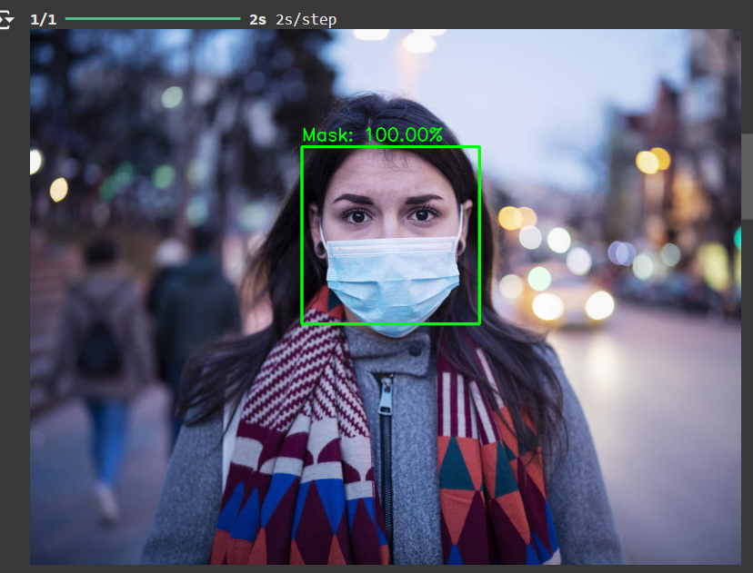**predicted output**

input_image = cv2.imread("image4.jpg")

output = face_mask_detector(input_image)

cv2_imshow(output)

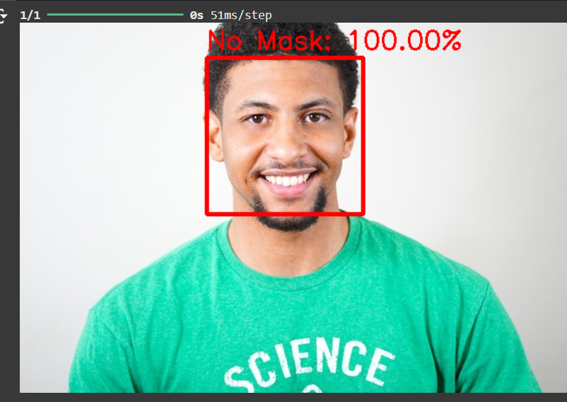**predicted output**